**Abstract Data Type Methods:**

**SQL Query:**

Create type employee_t as Object(

name varchar2(30),

ssn varchar2(30),

salary NUMBER,

member function raise_sal

return number

);

-- TYPE CREATED..

create type body employee_t as

Member function raise_sal return Number is

Begin

return salary*2;

end;

end;

-- TYPE CREATED..

-- Query For the Table Creation:

create table emp2 of employee_t;

-- Add / Insert Elements into the emp2 table

insert into emp2 values(

employee_t('Frank','12345',1000)

);

insert into emp2 values(

employee_t('Onkar','15645',1300)

);

insert into emp2 values(

employee_t('Adi','154345',3000)

);

insert into emp2 values(

employee_t('Raju','124545',2000)

);

insert into emp2 values(

employee_t('AAfan','12655',1600)

);

**-- Select elements from the table**

select * from emp2;

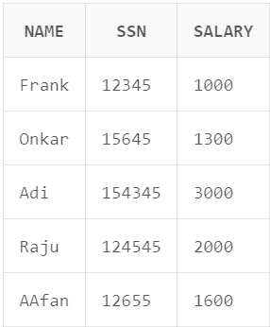

select e.raise_sal() from emp2 e;

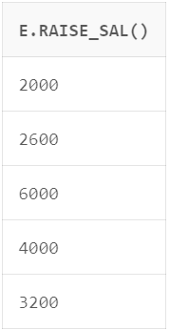

select e.name , e.raise_sal() from emp2 e;

